# Part 2

## Part 2(i)

**Hand in your values for the damping ratio and natural frequency that you calculated.**

Poles of transfer function =

-11.4016 + 0.0000i

-0.1692 + 4.8035i

-0.1692 - 4.8035i

Polynomial with complex roots = [1.0000 0.3384 23.1020]

wn = 4.8065 [rad/s]

damping = 0.0352 [ ]

## Part 2(ii)

**Hand in the Bode plot of G_alpha. Determine |G(alpha)| from the Bode plot for w = 3 rad/s, and 7 rad/s.**

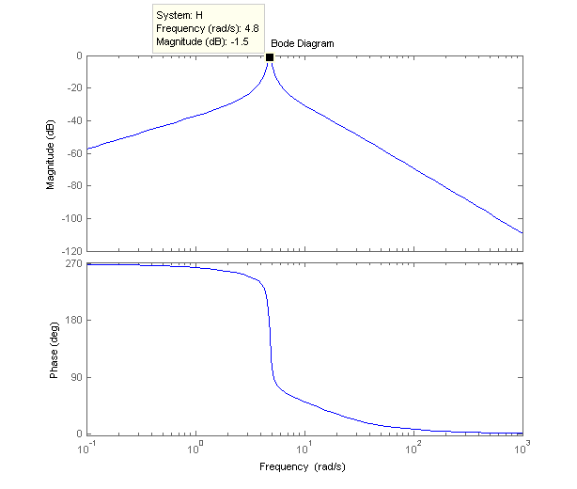

W = 3 rad/s

MAG = 0.0635

PHASE = 251.1411 [deg]

W = 7 rad/s

MAG = 0.0709

PHASE = 63.6780 [deg]

Part 2 code:

clc; clear; close all;

%% Given constants

Rm = 2.6; %motor armature resistance (ohms)

Lm = 0.18; %motor armature inductance (mH)

Kt = 0.00767; %motor torque constant (N-m/A)

nu_m = 1; %motor efficiency ()

Km = 0.00767; %back-electromotive-force(EMF) constant (V-s/rad)

Jm = 3.90E-07; %rotor moment of inertia (kg-m^2)

Kg = 3.71; %planetary gearbox ratio ()

nu_g = 1; %planetary gearbox efficiency ()

Mc2 = 0.57; %cart mass (kg)

Mw = 0.37; %cart weight mass (kg)

Mc = 1.0731; %total cart weight mass including motor inertia (kg)

Beq = 5.4; %viscous damping at motor pinion (N-s/m)

Lt = 0.99; %track length (m)

Tc = 0.814; %cart travel (m)

Pr = 1.664E-3; %rack pitch (m/tooth)

rmp = 6.35E-3; %motor pinion radius (m)

Nmp = 24; %motor pinion number of teeth ()

rpp = 0.01482975; %position pinion radius (m)

Npp = 56; %position pinion number of teeth ()

KEP = 2.275E-5; %cart encoder resolution (m/count)

Mp = 0.23; %long pendulum mass with T-fitting (kg)

Mpm = 0.127; %medium pendulum mass with T-fitting (kg)

Lp = 0.6413; %long pendulum length from pivot to tip (m)

Lpm = 0.3365; %medium pendulum length from pivot to tip (m)

lp = 0.3302; %long pendulum length: pivot to center of mass (m)

lpm = 0.1778; %medium pendulum length: pivot to center of mass (m)

Jp = 7.88E-3; %long pendulum moment of inertia _ center of mass (kg-m^2)

Jpm = 1.2E-3; %medium pendulum moment of inertia _ center of mass (kg-m^2)

Bp = 0.0024; %viscous damping at pendulum axis (N-m-s/rad)

g = 9.81; %gravitational constant (m/s^2)

%% Pre-lab Part 2.1

%Part 2(i) : Hand in your values for the damping ratio _ and natural frequency !n that you calculated.

denom = [1 11.74 26.96 263.4];

r = roots(denom)

poly1 = poly(r(2:3))

wn = sqrt(poly1(3))

damping = poly1(2)/(2*wn)

%bode plot

H = tf([-3.526 0],[1 11.74 26.96 263.4]);

bode(H)

[MAG, PHASE] = bode(H,3)

[MAG, PHASE] = bode(H,7)

# Part 3

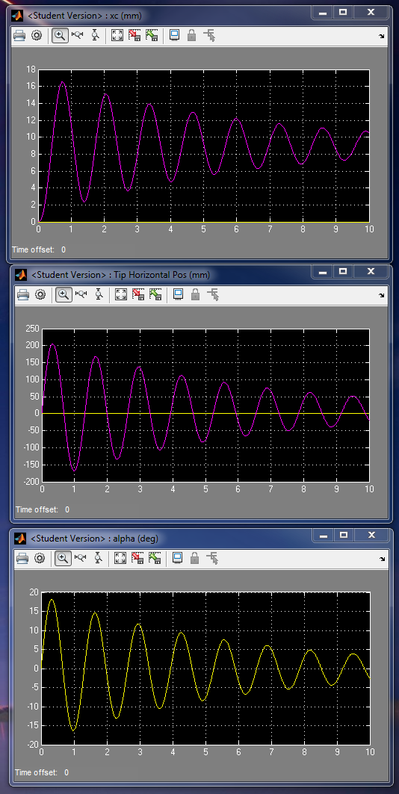

Alpha_dot_ 0 = pi/2 rad/s

K = 0 🡪 no control

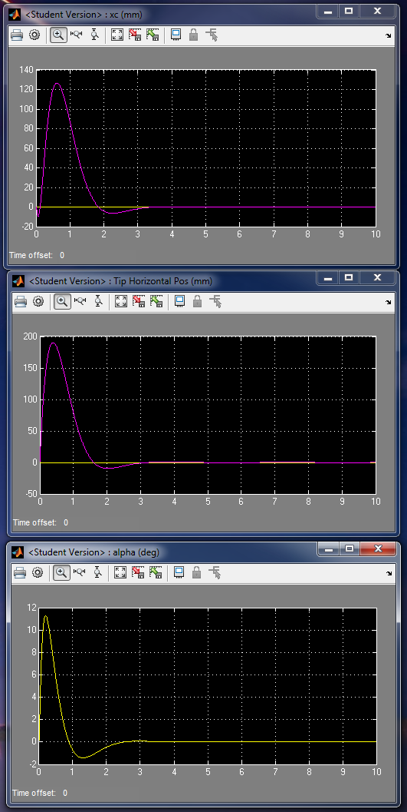

Alpha_dot_ 0 = pi/2 rad/s

K = chosen by MATLAB PLACE method 🡪 controlled pendulum

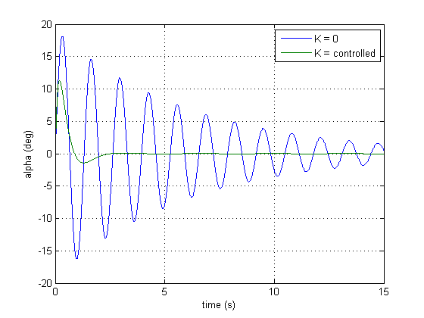

Comparison of controlled to uncontrolled pendulum angle simulation

Chosen roots:

-1.8182+1.9067i

-1.8182-1.9067i

-10

-20

Resulting K value = [40.1339 -63.9534 19.3025 2.1663]

**Code:**

p3 = -10

p4 = -20

K = place (A,B,[(-1.8182+1.9067i), (-1.8182-1.9067i), p3, p4])

# Part 4

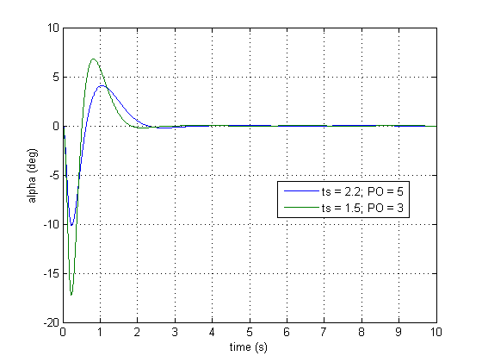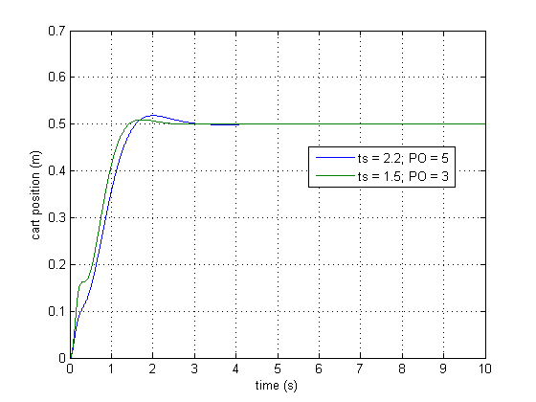

## First try

For ts = 2.2, PO = 5%,

Roots =

-1.8182+1.9067i

-1.8182-1.9067i

-10

-20

-30

k = 1.0e+03 * [0.8476 0.0072 0.2375 0.0884 -1.2040]

5% settling time = 1.4119 [s]

## Second Try 🡪 BEST K values

For ts = 1.5, PO = 3%,

Damping = 0.7448

Wn = 3.5805 [rad/s]

Roots =

-2.6667 + 2.3891i

-2.6667 - 2.3891i

-10

-20

-30

K = 1.0e+03 * [1.3256 0.1847 0.2550 0.0955 -2.2235]

5% settling time = 1.2314 [s]

Part 4 code:

Ai = [A, zeros(4, 1);-1, 0, 0, 0, 0]

Bi = [B; 0]

p3 = -10

p4 = -20

p5 = -30

K = place (Ai,Bi,[(-1.8182+1.9067i), (-1.8182-1.9067i), p3, p4, p5])

sim('aae364gantry2')

figure(1)

plot(p_out.Time,p_out.Data)

hold all

figure(2)

plot(alpha_out.Time,alpha_out.Data)

hold all

p_properties = stepinfo([0;p_out.Data],[0;p_out.Time],0.5,'RiseTimeLimits',[0 1],'SettlingTimeThreshold',0.05)

alpha_properties = stepinfo([0;alpha_out.Data],[0;alpha_out.Time],0.5,'RiseTimeLimits',[0 1],'SettlingTimeThreshold',0.05)

PO = 3;

ts = 1.5;

damping = abs(log(PO/100))/sqrt(log(PO/100)^2+pi^2)

wn = 4/(ts*damping)

poly2 = [1 2*damping*wn wn^2];

r = roots(poly2)

p1 = r(1);

p2 = r(2);

K = place (Ai,Bi,[p1, p2, p3, p4, p5])

sim('aae364gantry2')

figure(1)

plot(p_out.Time,p_out.Data)

grid on

legend('ts = 2.2; PO = 5','ts = 1.5; PO = 3',0)

xlabel('time (s)')

ylabel('cart position (m)')

figure(2)

plot(alpha_out.Time,alpha_out.Data)

grid on

legend('ts = 2.2; PO = 5','ts = 1.5; PO = 3',0)

xlabel('time (s)')

ylabel('alpha (deg)')

p_properties = stepinfo([0;p_out.Data],[0;p_out.Time],0.5,'RiseTimeLimits',[0 1],'SettlingTimeThreshold',0.05)

alpha_properties = stepinfo([0;alpha_out.Data],[0;alpha_out.Time],0.5,'RiseTimeLimits',[0 1],'SettlingTimeThreshold',0.05)